# Project Overview:

This project is focused on a food connect application to manage food donations and distribution, designedto address the problem of food waste and hunger. The goal is to deliver a comprehensive solution by leveraging the Salesforce platform and integrating modern tools like mobile applications and community portals.Through this project, we aim to streamline the donation process, improve collaboration between donors, recipients, and volunteers, enhance data visibility, and support the long-term mission of reducing food insecurity and waste.

1. **Objectives :**

* Create forms for donorsand recipients to submit and track donations.
* Set up a comprehensive Salesforce environment to manage food donations, inventory, and logistics.
* Streamline the entire process of food donationand distribution to make it more efficient and user- friendly.
* Automate the matchingof food donationswith recipients to save time and reduce manual effort.
* Enable real-time tracking of food deliveries using Salesforce and integrated tools.
* Provide insightful dashboards and reports to monitor donationtrends and impact.
* Foster collaboration throughcommunity portals for donor.

# Salesforce Key Features and Concepts Utilized :

# 

* Salesforce objects
* Classes
* Flows
* Triggers
* Creation of Fields
* Creation of Users
* Sales force app builder
* Creation of Public Groups
* Creation of Reports
* Lightning components

**4. Detailed Steps to Solution Design****:**

* + Create objects:
* Salesforce objects are the data containers, the structure where the data will be stored, with standard objects (the ones that comes pre-built like Account, Contact) and custom objects, created by you for specific business needs. By navigating to Setup, leveraging the Object Manager to set labels, properties and relationships, and then defining fields, page layouts, and access controls, users can create a custom object. You can also generate automation processes via workflows or flows. Salesforce's dynamic capabilities are augmented by custom objects that facilitate the realization of specific organizational requirements.

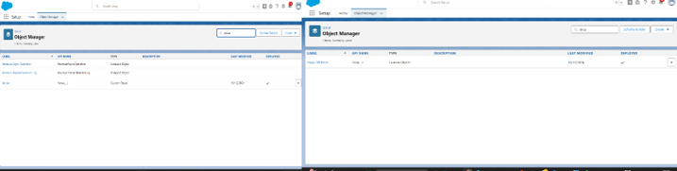

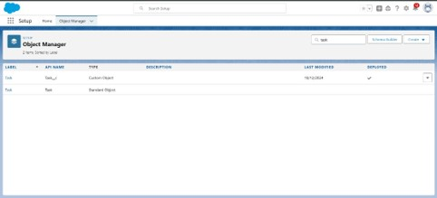

* Creating Flows and Fields:

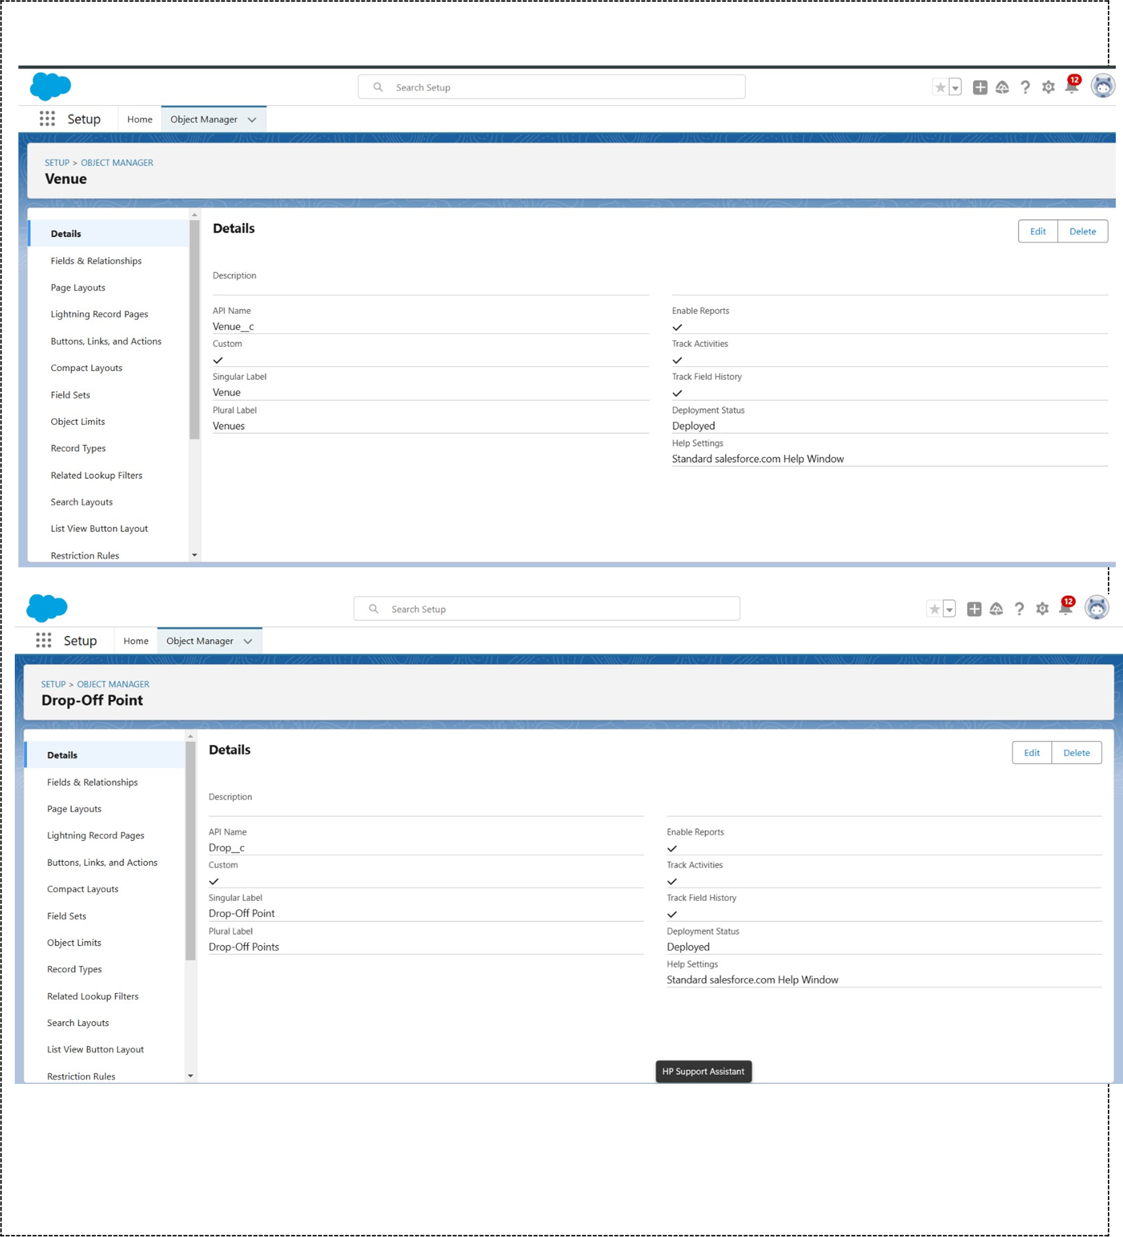In Salesforce, Flows are created through the Flow Builder, allowing automation of processes like data updates and record creation. To create a flow, navigate to Setup, select Flows, and define the flow type (e.g., Screen Flow or Record-Triggered Flow). Fields are added by going to the Object Manager, selecting an object, and creating custom fields for data storage (e.g., text, number, or date). Both flows and fields help customize Salesforce to automate processes and capture necessary data.

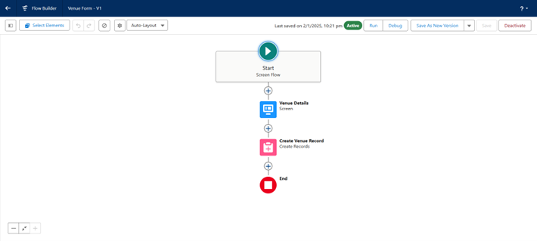

* creating triggers:

In Salesforce, Triggers are created to automate actions based on record changes (like insert, update, or delete). To create a trigger, navigate to Setup, go to Apex Triggers, and select New to write the trigger code. Triggers are written in Apex and are linked to specific objects. They execute before or after a record is saved, allowing customization of business logic and data processing.

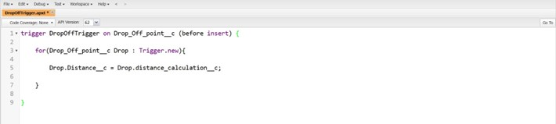

* creation of Users:

To create a user in Salesforce, go to Setup and search for Users under the "Manage Users" section. Click New User and fill in details such as name, username, email, and profile. Select the user's role, license, and permissions based on their responsibilities. After saving, the user will receive an activation email to complete the setup process.

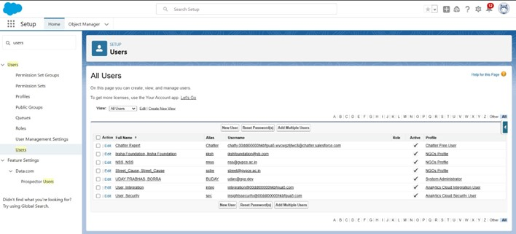

* Creation of public groups:

To create a Public Group in Salesforce, go to Setup and search for Public Groups under the "Manage Users" section. Click New Group, then provide a name and description for the group. Add members by selecting users, roles, or other groups. Save the group, and it can be used for sharing rules and access control.

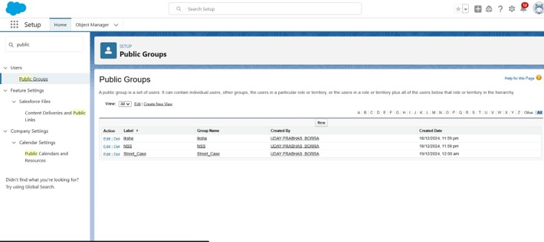

* Creation of ReportTypes:

To create a Custom Report Type in Salesforce, go to Setup and search for Report Types. Click New Custom Report Type, choose the primary object and define its category. Select the related objects and their relationships, then define the layout and fields to include. After saving, the custom report type can be used to create tailored reports.

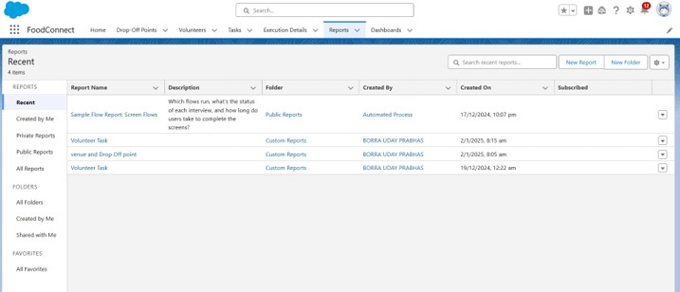

* create app page using app builder:

To create an app page in Salesforce using App Builder, go to Setup and search for App Builder. Click New and select App Page to create a new page. Use the drag-and-drop interface to add components like charts, lists, or reports. After designing, save and activate the page, making it accessible to users in your app.

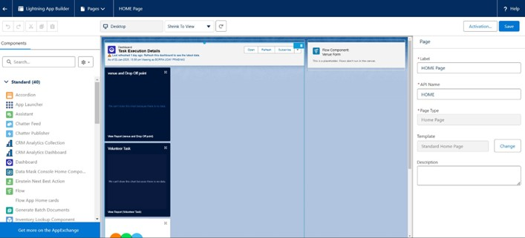

# 

# 5.**Testing and Validation Describe the approach to testing**:

Tested all the Users, Reports and Dashboard clearly so that there will be no flaws in end application

**6.Key Scenarios Addressed by Salesforce in the** **Implementation Project:**

Simplifies and streamlines the entire process of managing food donations and distribution with an intuitive user interface for both administrators and end users.The platform enhancescollaboration between donors, recipients, and volunteers, ensuring a seamless experience for all stakeholders while maximizing efficiency and impact.

**7. Conclusion Summary of Achievements:**

Gained a comprehensive understanding of the Salesforce environment and successfully implemented various tools and features to streamline food donation and distribution processes. Enhanced efficiency, collaboration, and data accuracy whileaddressing real-world challenges of food wasteand hunger throughthe Food Connect project.